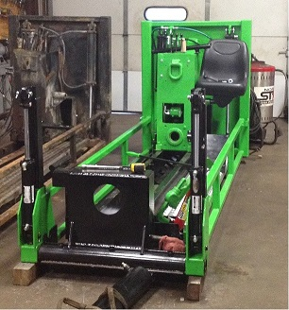**1824** - US House of Representatives begins to decide outcome of election deadlock between John Quincy Adams and Andrew Jackson (Adams wins).

##### **Superior Hydraulics Repair, a division of WorldWide Machining and Welding, Inc. has been busy this past month servicing the hydraulic needs of our customers.**

##### 

**Aug 1, 1941**- The cereal “Cheerios” hits the store shelves.

**Aug 1, 1941** - Slugger Mickey Mantle hits his first home run.

**Aug 3, 1937** - Margaret Mitchell wins Pulitzer prize for “Gone with the Wind”.

**Aug 6, 1833** - John Deere produces the first steel plow.

**Aug 8, 1974** - The US Post Office is established.

**Aug 17, 1875** - "And They're Off!" as the first Kentucky Derby is held at Churchill Downs.

**Aug 23, 1934** - Legendary bank robbers Bonnie and Clyde Barrow are shot to death in a police ambush in Louisiana.

**Aug 31, 1977** - The trans-Alaska pipeline is completed.

# Did You Know?

#### This month in history…

**1878 -** 1st White House telephone installed.

**1934 -** Leningrad mayor Sergey Kirov assassin

Stalin uses as excuse to begin the Great Purge of 1934-38.

**1998** - Exxon announces a $73.7 billion USD deal to buy Mobil, thus creating Exxon-Mobil, the world's largest company.

Superior Hydraulics Repair is currently pursuing new inventory and distributors to expand and grow our capabilities and to provide a growing list of services at a more competitive price, to better serve our customers. This includes cylinder repair, supply of seals and fittings, and hose builds. And we have business relationships to support your hydraulic pump and motor needs!

We also specialize in finding solutions for your problems. Our dedicated team with their combined years of experience will work with you to supply or build custom solutions for your unique project needs. Pictured above is a custom hydraulic plumbing job solution we are currently working on for one of our valued customers.

For more information regarding our hydraulic services, please reach out to us as our team is always available to you! You can also visit our website at wwmwinc.com

WorldWide

An Insider’s guide

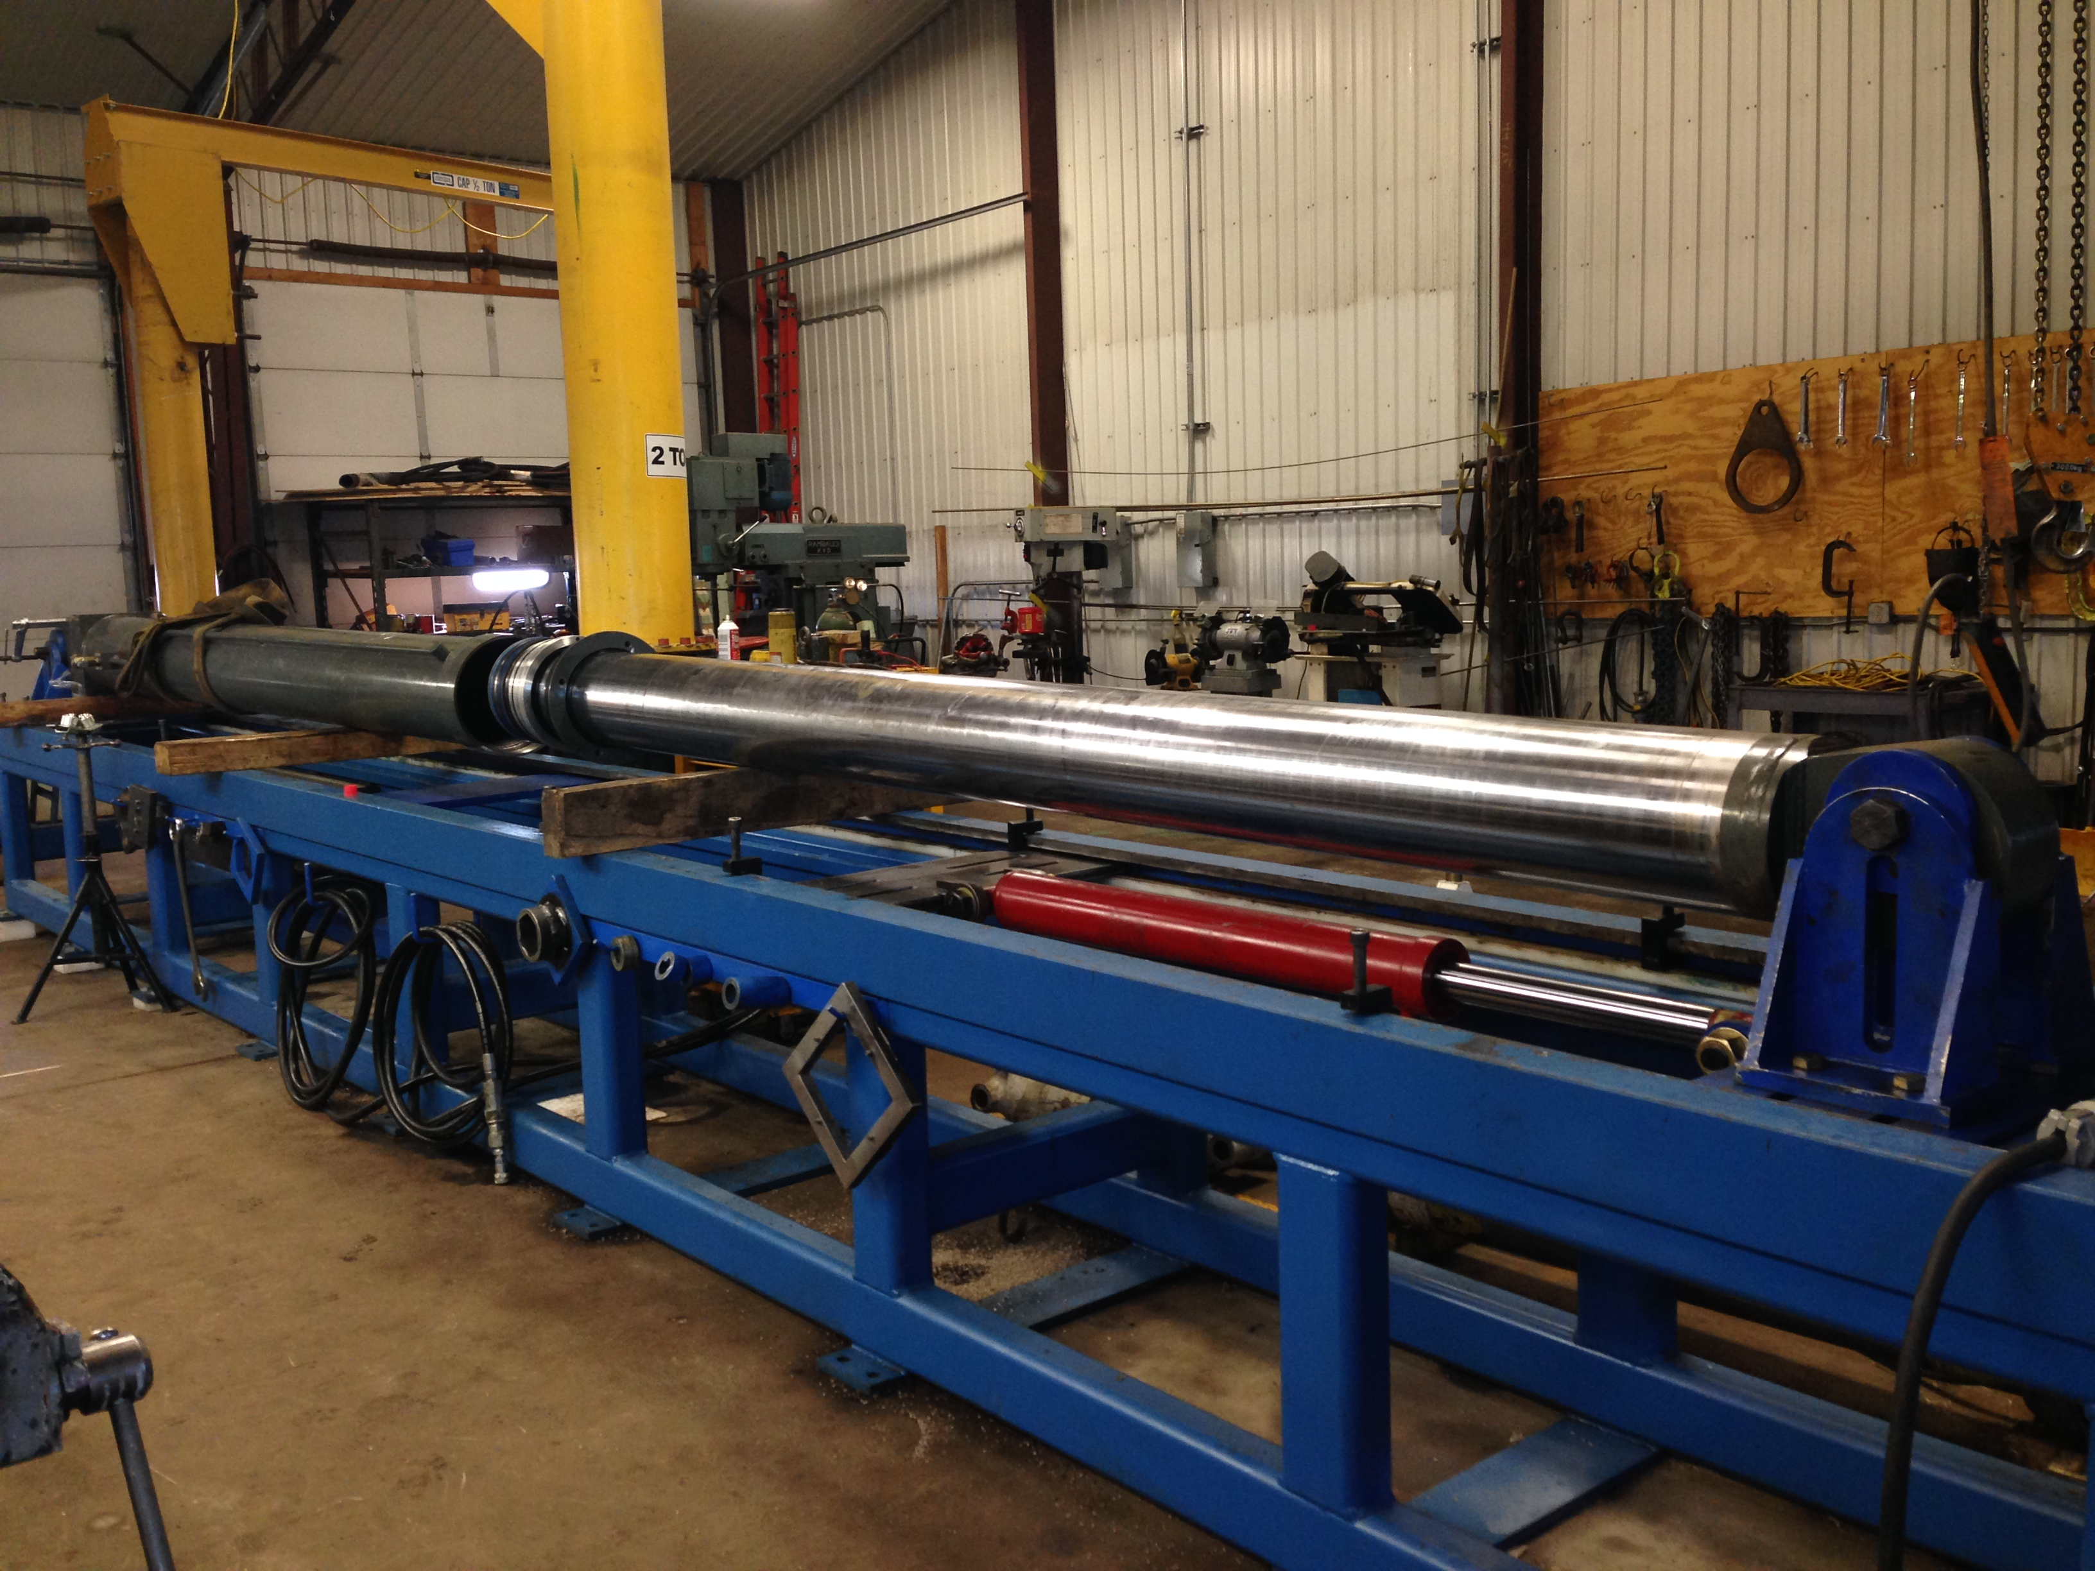

**Quote:**

**“Creativity is contagious, pass it on”**

**~Albert Einstein**

## Mission Statement: *“A team-driven organization striving to provide timely, high quality service and end products to our customers for a fair price in an* *atmosphere of honesty and dedication.”*

Email: sales@wwmwinc.com

Phone: 715.394.6006

Fax: 715.394.6007

